**Егорова Диана пр-21.101 СРС**

**23310 = 111010012**

**2n = 8 => n = 3, => три множества.**

**1 1 1 0 1 0 0 12 = 1*27+1*26 +1*25+0*24+1*23+0*22+0*21+1*20=23310**

7 6 5 4 3 2 1 0

**Двоичный вектор: {1, 1, 1, 0, 1, 0, 0, 1}**

1 1 1 0 1 0 0 1 2

|  |  |  |  |  |
| --- | --- | --- | --- | --- |
|  | **M1** | **M2** | **M3** | **M** |
| **0** | 0 | 0 | 0 | 1 |
| **1** | 0 | 0 | 1 | 0 |
| **2** | 0 | 1 | 0 | 0 |
| **3** | 0 | 1 | 1 | 1 |
| **4** | 1 | 0 | 0 | 0 |
| **5** | 1 | 0 | 1 | 1 |
| **6** | 1 | 1 | 0 | 1 |
| **7** | 1 | 1 | 1 | 1 |

**Диаграмма Эйлера:**

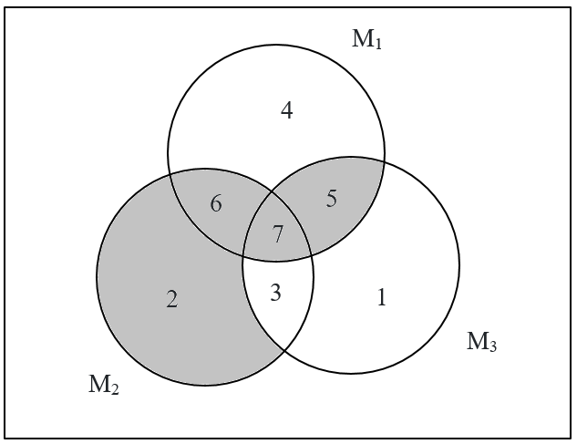

M1

4

5

6

3

1

2

7

M3

M2